**Cell Fractionation by Differential Centrifugation**

1. **Centrifuge**
2. **Rule**
3. samples in rotation around a fixed axis, the centrifugal force causes particles in your sample to accelerate toward the outer edge of the rotor.
4. The bottom of the sample tubes are at the outer edge of the rotor.
5. Large particles (e.g. cells) require less force than small particles (e.g. precipitated proteins)
6. RPM stands for "Revolutions per minute." A rotor, regardless of its size, is revolving at that rate.
7. RCF (relative centrifugal force) is measured in the force applied to the contents varies by * gravity or g-force. This is the force exerted on the contents of the rotor, resulting from the revolutions of the rotor.

**RCF = 1.1118 x 10-5 x r x rpm^2** (Where r is the rotor radius in centimeters)

1. **Function**

the sedimentation of particles to the bottom of the tube.

1. **Differential centrifugation**
2. works by a stepwise increase in the centrifugation speed.
3. Lower speeds at the beginning are used to eliminate the heavier particles from the sample, and the speed is then increased until the targets themselves are pelleted
4. **Staining**
5. Nuclei (DNA) and mitochondria (DNA) will be stained blue (methyl

green)

1. and cytoplasm (RNA) red (pyronin)
2. **Identification of Mitochondrial fraction**
3. **SDH-FAD-DCPIP**

* **SDH:** catalyzes the oxidation of succinate to fumarate in Krebs cycle. An inner mitochondrial membrane bound protein (a good marker for mitochondria)
* **FAD:**
* Flavine adenine dinucleotide (FAD) is a coenzyme covalently bound to the SDH enzyme
* For the enzyme to complete its catalytic cycle, the electrons it receives from succinate are ordinarily passed on down the electron transport chain to oxygen, and the reduced FAD becomes reoxidized, ready to encounter another succinate.

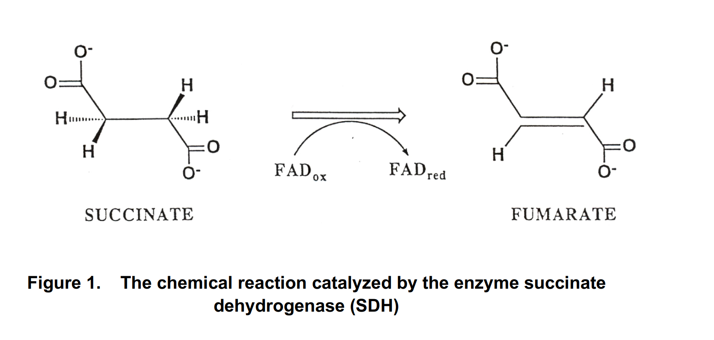

* **2, 6-dichlorophenol indophenol (DCPIP)**

One very useful artificial electron acceptor

* It absorbs strongly at 600 nm when oxidized,
* but becomes colorless in its reduced form.
* 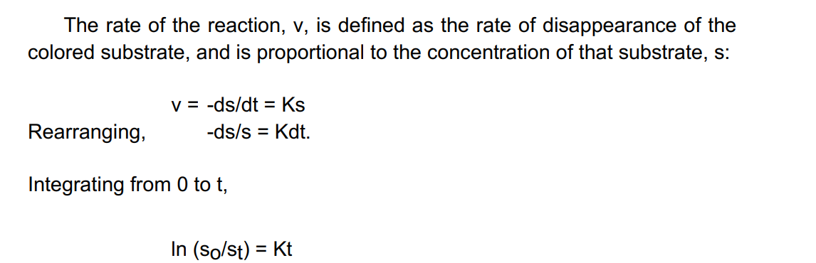

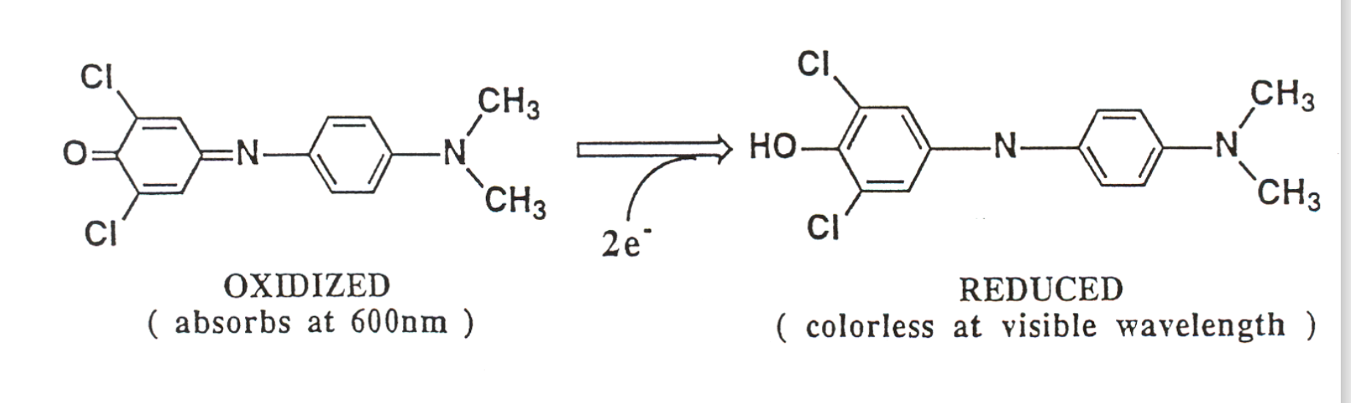

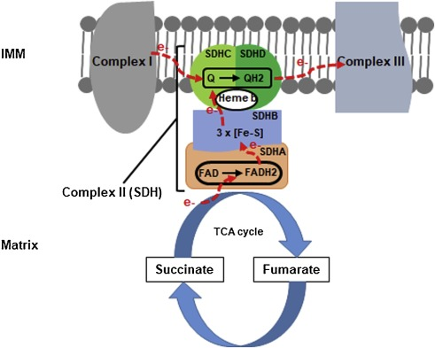

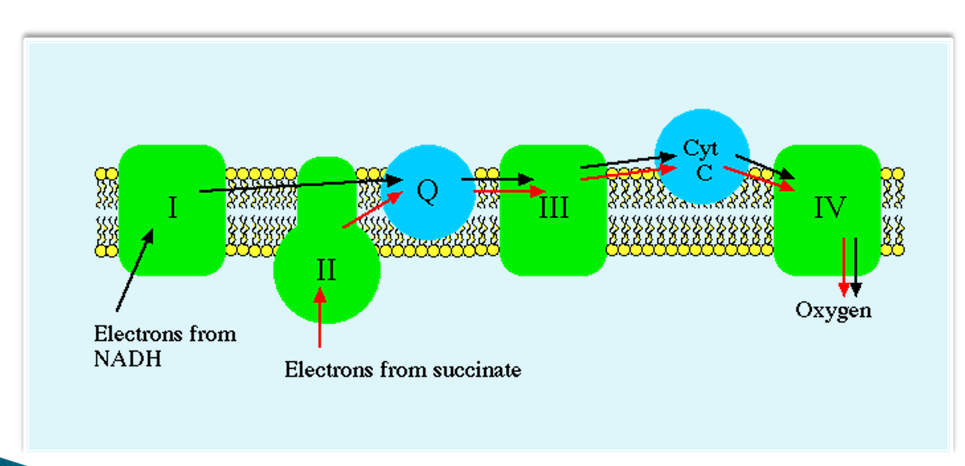

1. **Procedure**

**Part A separation of 4 fractions by centrifuge**

**I. Preparation of crude fraction**

1. Mix 2 g fresh rat liver into a 50 ml with 4 ml ice-cold buffered sucrose.

2. Put the tube on ice. Finely mince the tissue with scissors.

3. Transfer the tissue pieces with the ice-cold sucrose to a homogenizer vessel.

4. Add additional 5 ml ice-cold buffered sucrose to rinse the tubeand pour out all remaining tissues to the vessel again.

5. Homogenize the minced liver tissue for about 12 seconds (until no lumps

remain).

6. Add additional 4 ml ice-cold buffered sucrose to rinse the

homogenizer vessel. Keep cold throughout.

7. Decant the homogenate through a cell strainer into an ice-cold 50-ml

centrifuge tube. Rinse the homogenizer vessel with 5 ml ice-cold buffered sucrose and pour it through the cell strainer into the tube too.

8.Record the volume.

9. Save 2*1 ml of crude homogenate in two chilled 1.5 ml microfuge tubes and label it,

for assay and microscopy

10. Centrifuge the rest fraction for 10 min at 600g at 4C.

II. **Separation of Nuclear fraction**

1.For the pellet (which is the nuclei), resuspend in 10 ml buffered

sucrose.

2. Centrifuge again for 10 min at 600 g

3. Resuspend the pellet in 5 ml buffered sucrose, Save it on ice.

4. Save 2*1 ml of nuclear fraction in two chilled 1.5 ml microfuge tubes and label it,

for assay and microscopy

III. **Separation of Mitochondria and Soluble Fraction**

1. For the supernatant from Step I, carefully transfer it to another high speed centrifuge tube (do not disturb the pellet). Centrifuge again for 20 min at 20,000 g at 4C (Note that the error of trim need to be less than 0.1g)

2.**For soluble fraction**

(1) Carefully transfer the supernatant from III-1 to another chilled test tube (do not

disturb the pellet). Save it on ice.

(2) Record the volume.

(3) Save 2*1 ml of soluble fraction in two chilled 1.5 ml microfuge tubes and label it,

for assay and microscopy

3. **For mitochondria**

(1) For the pellet from III-1, resuspend in 5 ml ice-cold sucrose. Save it on ice.

(2) Save 2*1 ml of crude homogenate in two chilled 1.5 ml microfuge tubes,

for assay and microscopy

**Part B: Observation by microscope**

1. **For the protein assay in next week**

Saved 1 ml of crude homogenate and all three fractions to instructor

2. **For the microscopy observation of samples**

(1) Add 10 ul of the fraction on a clean slide.

(2) Spread the drop with the edge of a second slide to make a smear.

(3) Allow the slide to air dry.

(4) Add 10 ul of stain (methyl green pyronin). Let sit 3 minutes.

(5) Invert the slide and immerse slide in a rack in a pan of SLOW running

tap water for about 30 seconds.

(6) Add 10 ul glycerin and a coverslip.

(7) Observe in bright field.

**Part C: Protein Assay**

**1.Dillute sample**

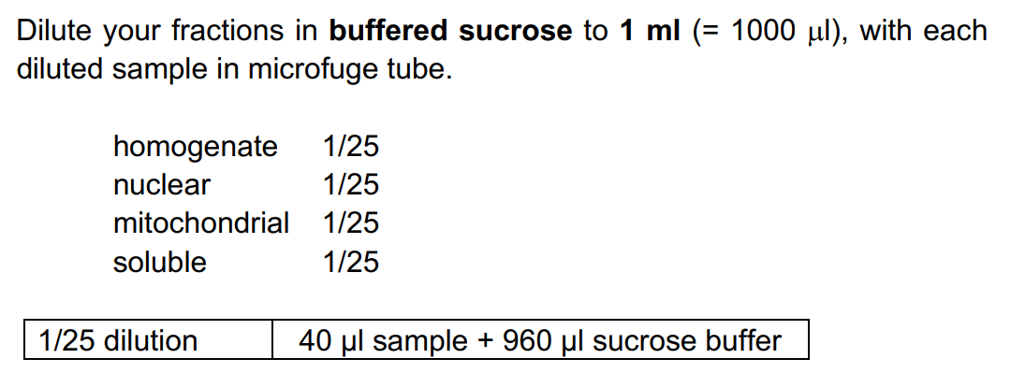

1. **Protein assay**
2. **standard**

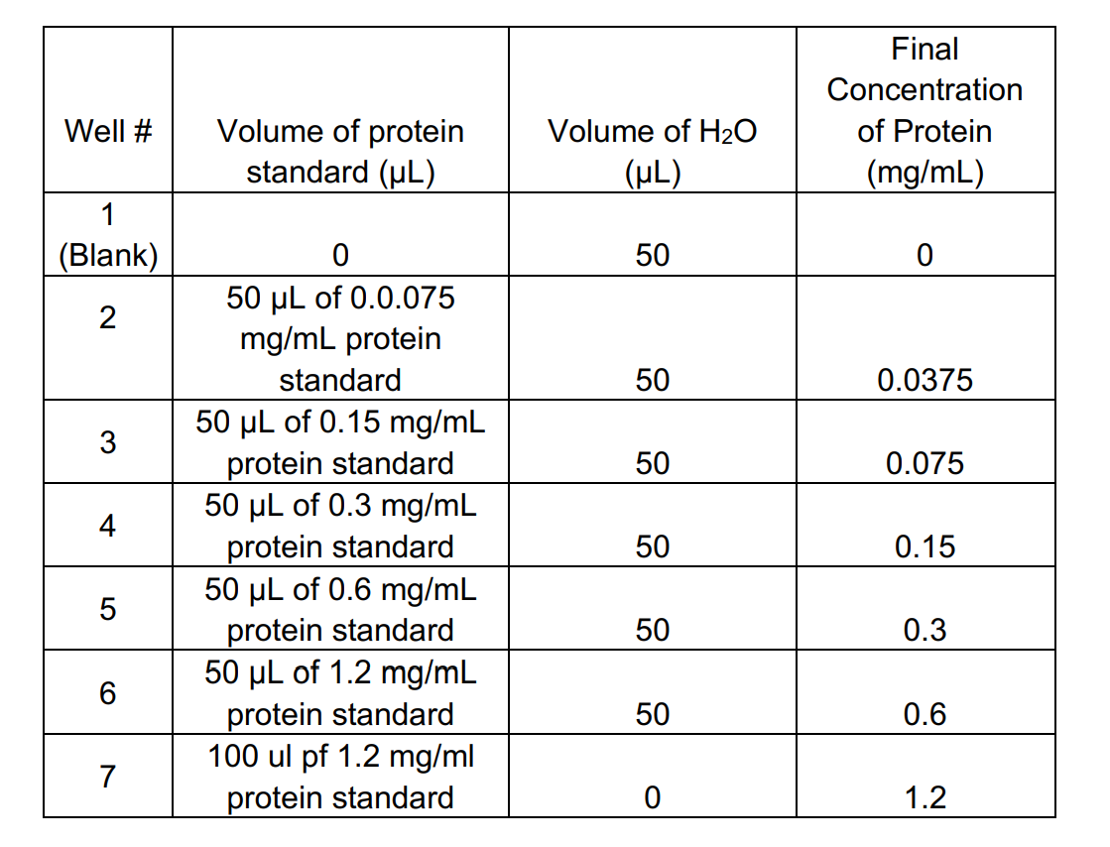

1. **Add 10 μL of standards to the appropriate wells. Then add 200 μl of Bradford reagent to each well. Mix the contents well. Wait for 3-minutes**
2. **Repeat Step 2 for the following diluted samples**
3. After 3-minutes, **measure absorbance at 595 nm** with microplate spectrophotometer (BioTek Epoch plate reader). Record the absorbance value on the datasheet

**Part D: Succinate Dehydrogenase (SDH) Assay**

1. **Centrifuge homogenate and nuclear fraction at 600x g, 5min.**
2. **Add 10 μL of the following samples to the appropriate wells. Then add 180μl of pre-warm assay medium (Solution 3+4) to each well. Mix the contents well.**

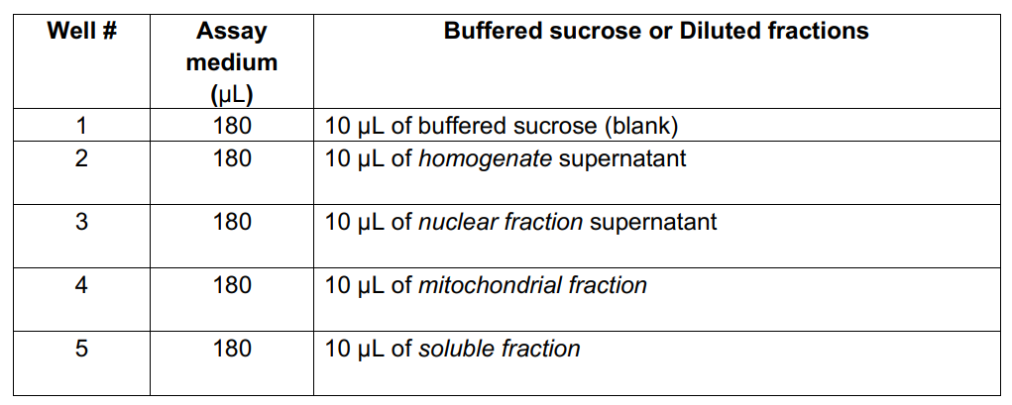

1. Then add 10 μl of Solution 5 to each well. **Mix the contents well**
2. Measure absorbance at 0 min and 2 min (600 nm) with microplate spectrophotometer (BioTek Epoch plate reader). Record the absorbance value on the datasheet